**Design Of Counters**

**4 Bit Asynchronous Counter**

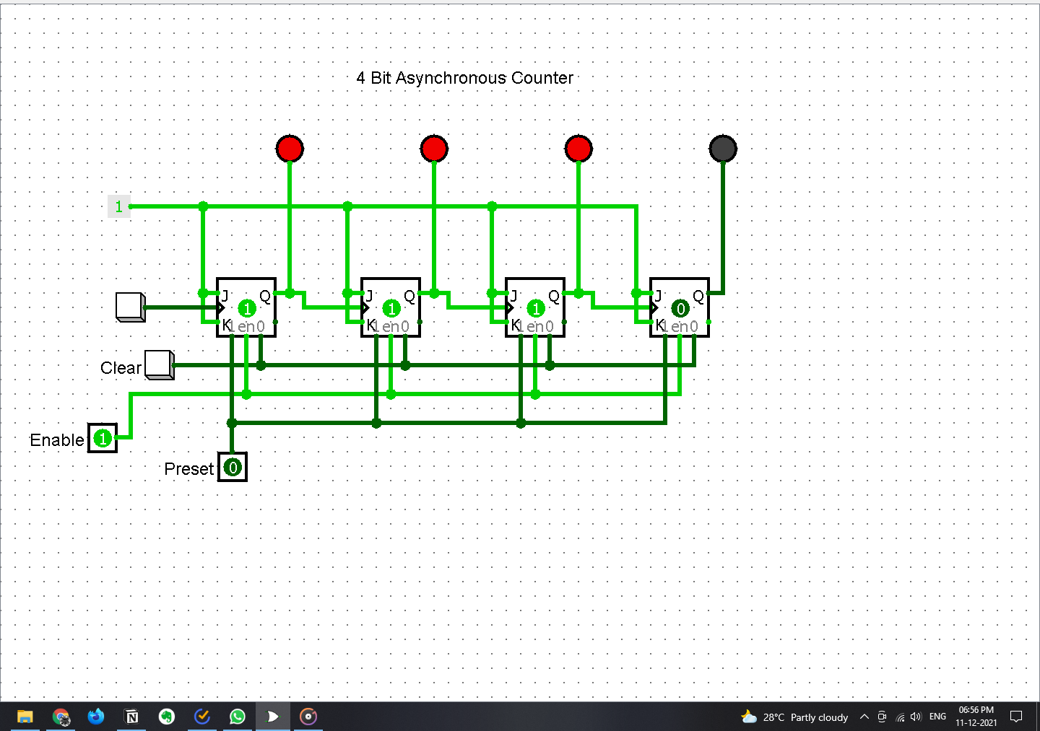

**MOD 10 Asynchronous Counter**

